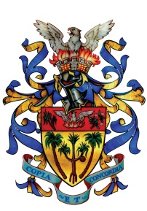

**in collaboration with**

**MUNICIPAL COUNCIL OF VACOAS/PHOENIX**

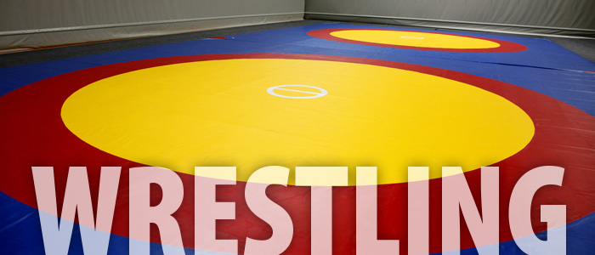

**Mauritius National Wrestling &**

**Allied Games Association**

**Independence Regional Wrestling Competition 2016**

**Sunday 22nd May 2016 as from 9.00 am**

**Venue: New Wrestling Competition Hall, Vacoas**